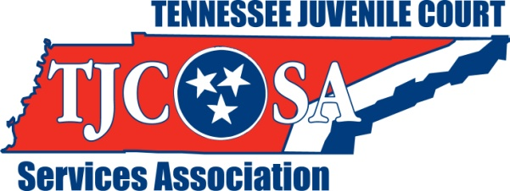

Tennessee Juvenile Court Services

Association’s 2024 Awards’ Application

Your participation is welcomed in helping the Association identify and recognize significant individuals, organizations and programs that have been outstanding in their contributions to the children and Juvenile Courts of Tennessee.

You are encouraged to submit nominations for consideration that will be awarded during the Association’s 41st Annual Conference on Juvenile Justice which will be held at the Franklin Marriott Cool Springs & Convention Center
700 Cool Springs Blvd Franklin, TN 37067. Below is the list of awards:

Meritorious Service Award
This award is presented to the individual, group of persons or organizations deserving honor for their significant contributions to the Juvenile Courts of Tennessee

Humanitarian Award
This award is presented to the individual, group of persons, or organizations for their involvement in helping to improve the welfare of children and families across the State of Tennessee

Outstanding Juvenile Court Worker Award
This award is presented to a Juvenile Court staff person who has contributed to their Court’s improvement

Outstanding Juvenile Court Probation/Youth Services Officer Award
This award is presented to a Juvenile Court staff person who has made a difference in the field of Juvenile Justice

Outstanding Juvenile Court Supervisor/Administrator Award
This award is presented to a Manager/Administrator from a Juvenile Court in the State of Tennessee who has made a difference in the field of Juvenile Justice

To nominate an individual, organization or program in these categories, please provide the following information:

Nominee Name: ___________________________________________________
Position currently held: ______________________________________________
Court, Program or Organization: _______________________________________
Address: _________________________________________________________
_________________________________________________________________
Phone: ______________________e-mail________________________________

For the Following Award:
___ Meritorious Service Award
___ Humanitarian Award
___ Juvenile Court Worker Award
___ Probation/Youth Services Officer Award
___ Supervisor/Administrator Award

(Please check only one award per form)

Please attach a separate sheet of paper stating why you feel this person or
organization/program should be given this award. Explain in detail how this
person or group has improved or impacted your court system or other court
systems in Tennessee. Be sure to include their length of membership and/or
involvement with TJCSA and the Juvenile Justice System. Newspaper articles,
recognitions or other awards may be included as well as statements from
individuals supporting this nomination. Consideration will be given to
each nominee. We appreciate your participation.

Nomination Submitted by: _________________________________________
Position: _______________________________________________________
County/Address: _________________________________________________
_______________________________________________________________
Phone: _____________________e-mail_______________________________

Please return your completed nomination application by May 31, 2024 to:

Mary Ann Smith maryannsmith@jisnashville.gov
Davidson County Juvenile Court
100 Woodland Street
P.O. Box 196306
Nashville, TN 37219-6306

(NO LATE NOMINATIONS ACCEPTED)

