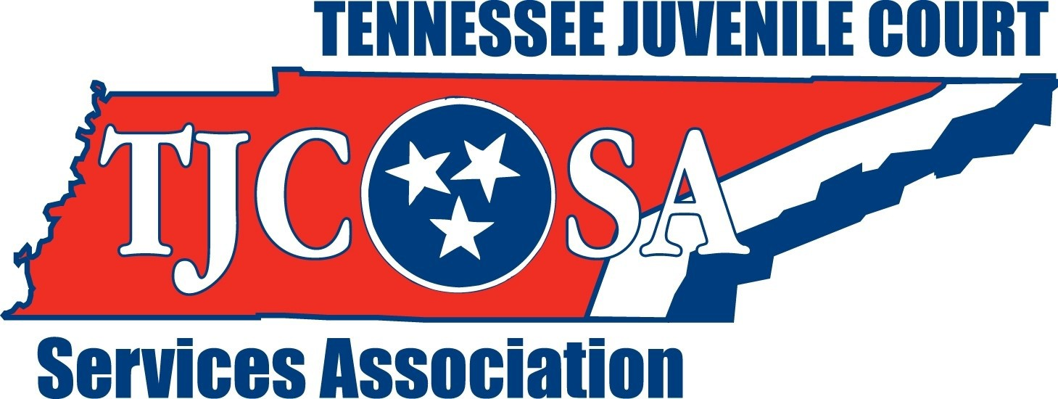
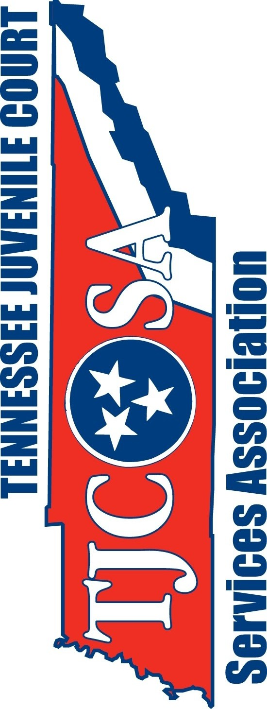
Don’t Wait…. Join with other Professionals!!

Plan to attend the
40th Annual Conference on Juvenile Justice To be held at the
Tennessee Juvenile Court Services Association Davidson County Juvenile Court
Attn: Justin Campbell
3323 Division Street Knoxville, TN 37919
Woodland Street
Nashville, TN 37213
Marriott Knoxville Downtown & Convention Center
525 Henley Street
Knoxville, TN 37902
865-522-2800
August 13-16, 2023 Mark Your Calendar!!!

WHY YOU SHOULD BELONG...
The Tennessee Juvenile Court Services Association can help you become more effective in resolving problems with which you are confronted daily.
TJCSA was founded in 1973 by a group of dedicated Juvenile Court professionals interested in improving the juvenile justice system. By joining the TJCSA you will have the opportunity to work with other professionals in serving the needs and interests of children in Tennessee.

PURPOSE…
* To provide a vehicle for sharing of solutions to common problems and for developing services to the Juvenile Courts of Tennessee.
- To create avenues for regular exchange of ideas and techniques employed in the respective areas of administration, detention care, probation services, and court clerk responsibilities.
- To unite members in the acceptance of a standard of conduct and code of ethics by which they agree to abide in the performance of their duties.
Mail to:
- To aid in the development of community programs and services and to give regional and state wide support to efforts of shared interest being put forth by the allied professional organizations.

MEMBERSHIP BENEFITS PROVIDE YOU WITH:
1. Conferences, regional meetings and training presented and sponsored by the Association to assist in obtaining credits to maintain professional certification
Tennessee Juvenile Court Services Association Knox County Juvenile Court
3323 Division Street
Knoxville, TN 37919
Attn: Justin Campbell
2. The support of other juvenile justice professionals.
3. A forum for the exchange of ideas and experiences which will help you with the problems encountered in your work with troubled children and their families.
4. Enhancement of your professional integrity.
5. Representation of your ideas and concerns, both within your region and the state
6. Newsletters with timely updates on juvenile justice information and other related matters.

TENNESSEE JUVENILE COURT SERVICES ASSOCIATION
Regular TJCSA Membership (Open only to Juvenile Court Personnel) $40.00
Name: Position: Organization: Address:
City: State: Zip: Phone:

