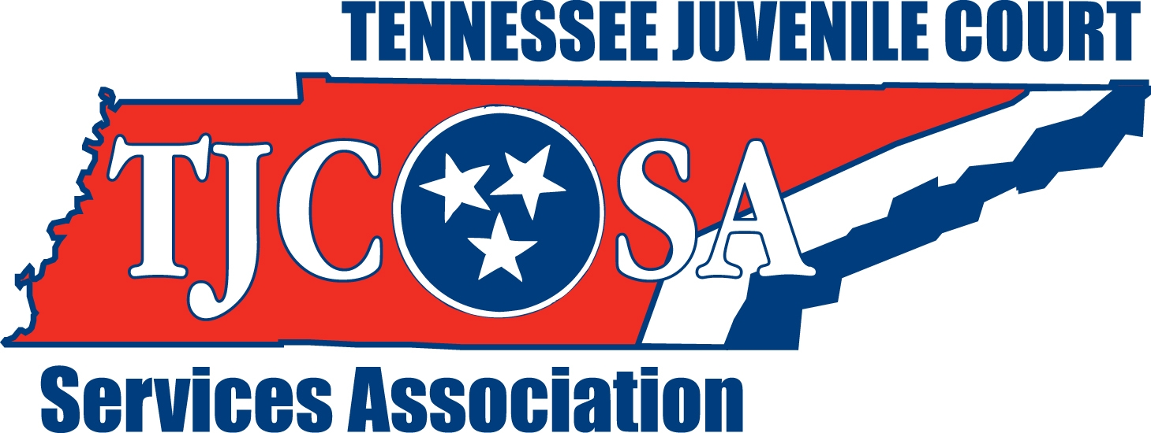

TJCSA EXECUTIVE COMMITTEE APPLICATION

NAME: _____________________________________________________________

POSITION: __________________________________________________________

COURT AND COUNTY: _______________________________________________

ADDRESS: __________________________________________________________

____________________________________________________________________

TELEPHONE: ________________________________________________________

E-MAIL: ____________________________________________________________

LENGTH OF MEMBERSHIP IN TJCSA: __________________________________

INVOLVEMENT WITH TJCSA: ________________________________________

____________________________________________________________________

____________________________________________________________________

____________________________________________________________________

LENGTH OF EMPLOYMENT IN JUVENILE JUSTICE SYSTEM: ____________

WHY DO YOU WISH TO SERVE ON THE EXECUTIVE COMMITTEE?

____________________________________________________________________

____________________________________________________________________

____________________________________________________________________

E-MAIL TO: maryannsmith@jisnashville.gov
DEADLINE: April 25, 2025

